- Secure Networks with Firewall

Q1. Set up Windows Defender Firewall on your Windows laptop or PC and create a new inbound rule to block all incoming traffic on port 8080. Take a screenshot of the rule you created?

Answer

- Blocking Incoming Traffic on Port 8080 Using Windows Defender Firewall
Aim
To create a new Inbound Rule in Windows Defender Firewall to block all incoming traffic on port 8080.
- Steps
- Open the Control Panel on the Windows PC.
- Click on System and Security.
- Open Windows Defender Firewall.
- Click on Advanced Settings from the left side.
- The Windows Defender Firewall with Advanced Security window will open.
- Click on Inbound Rules from the left side.
- Click on New Rule... from the right side.
- Select Port and click Next.
- Select TCP.
- Select Specific local ports and enter 8080.
- Click Next.
- Select Block the connection and click Next.
- Keep Domain, Private, and Public selected and click Next.
- Enter the rule name as Block Port 8080.
- Click Finish to create the rule.
- Result
The inbound firewall rule was created successfully. Windows Defender Firewall will now block incoming TCP traffic on port 8080.

Q2. Simulate NAT (Network Address Translation) by drawing a simple diagram showing how your home WiFi router assigns private IP addresses to your phone, laptop, and smart TV, and how it translates them to a single public IP for internet access.<br><br><em><strong>Hint:</strong> Use any drawing tool or even hand-draw and click a photo.</em>?

Answer
NAT stands for Network Address Translation. It is a technique used by a Wi-Fi router to allow multiple devices to access the Internet using a single public IP address.

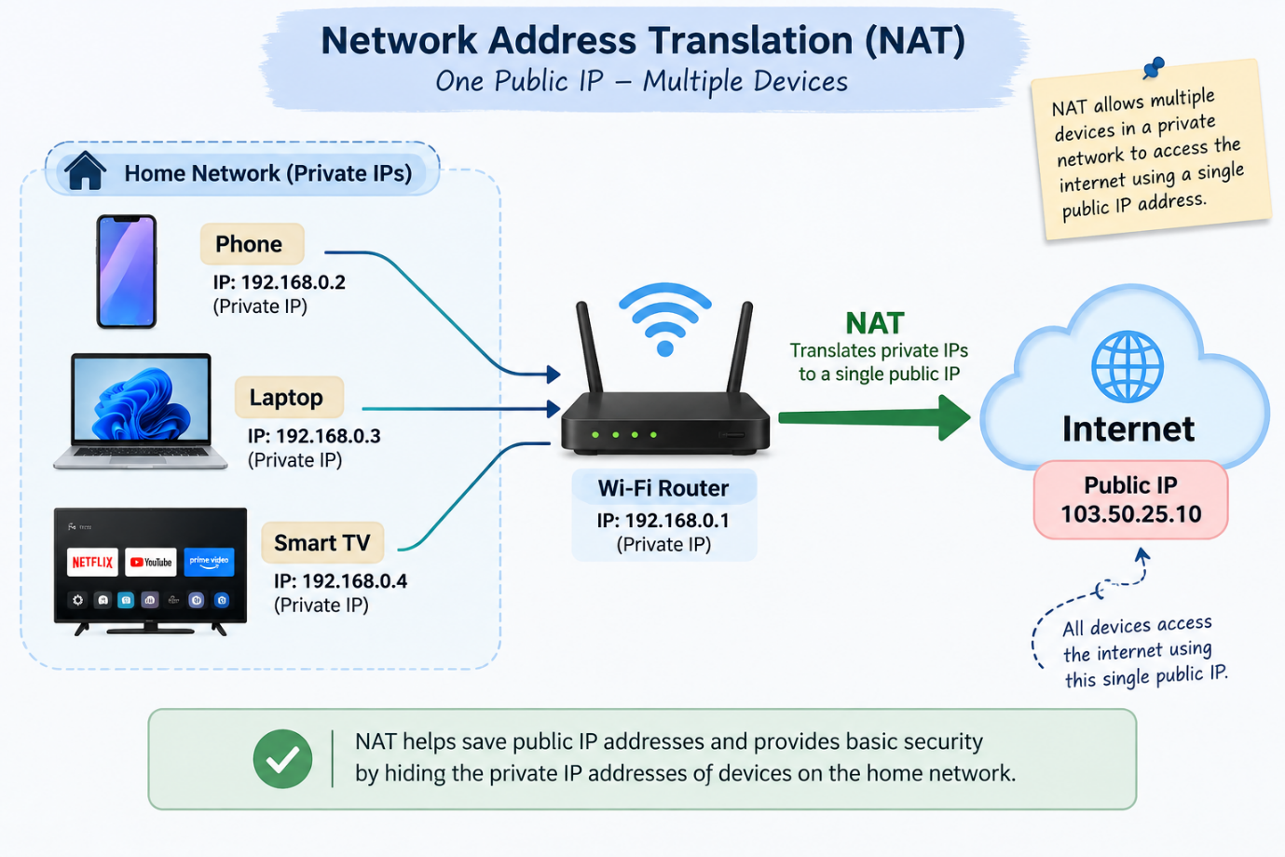
- In the diagram, the devices have different private IP addresses:
- Phone: 192.168.0.2
- Laptop: 192.168.0.3
- Smart TV: 192.168.0.4
- Wi-Fi Router: 192.168.0.1
- Public IP: 103.50.25.10
The phone, laptop, and Smart TV send their data to the Wi-Fi router. The router uses NAT to translate their private IP addresses into one public IP address before sending the data to the Internet.
- Conclusion:
NAT allows multiple devices in a home network to share one public IP address and also hides their private IP addresses from the Internet.

Q3. Configure port filtering using your WiFi router's admin panel (or use a router simulator online if you don't have access). Block outgoing traffic on port 25 (SMTP) and explain in 2 sentences how this could help prevent spam from your network?

Answer
Port filtering is used to control network traffic by allowing or blocking specific ports. In this task, I configured a port filtering rule to block outgoing traffic on Port 25, which is used for SMTP (Simple Mail Transfer Protocol).
- Configuration used:
- Rule Name: Block_SMTP
- Direction: Outbound (Outgoing)
- Protocol: TCP
- Destination Port: 25
- Action: Deny (Block)
- Status: Enabled
- Steps:
I opened the router admin panel and went to Security → Port Filtering. I created a new rule, selected Outbound traffic, chose TCP, entered 25 as the destination port, selected Deny (Block), enabled the rule, and saved the settings.
- How it helps prevent spam:
Blocking outgoing Port 25 can prevent unauthorized programs or malware from directly sending emails using SMTP. This can help reduce spam being sent from devices connected to the network
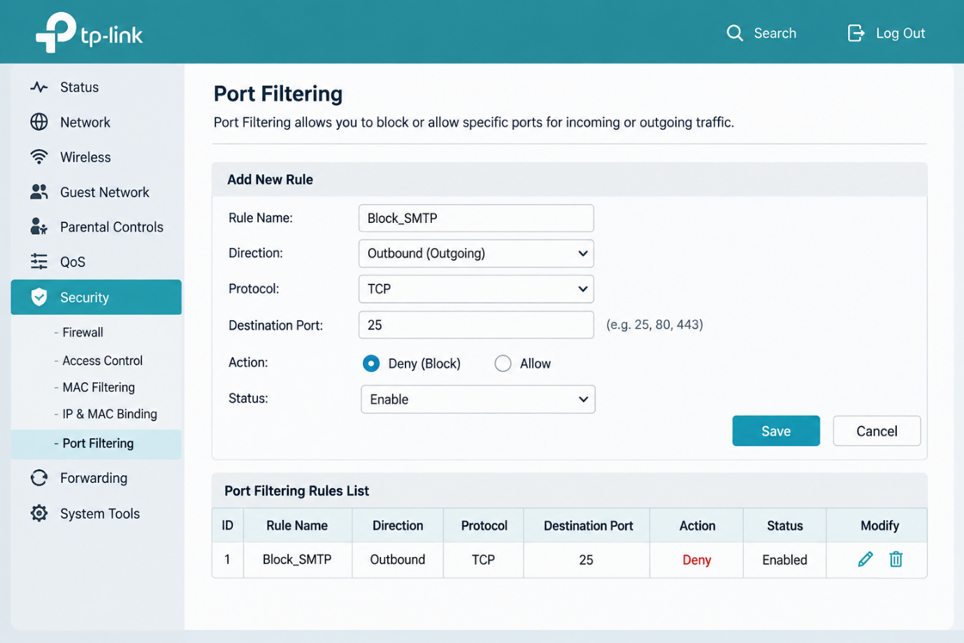

Q4. Given a sample packet filtering rule set (provided by your trainer), identify which of these three sample packets would be allowed or blocked: 1) HTTP request from 192.168.1.5 to 172.217.166.78:80, 2) SSH request from 10.0.0.10 to 34.201.23.1:22, 3) DNS query from 192.168.1.7 to 8.8.8.8:53.<br><br><em><strong>Hint:</strong> Focus on source/destination IPs and ports in the rule set.</em>?

Answer
Packet filtering checks information such as the source IP address, destination IP address, and port number to decide whether a packet should be allowed or blocked.
For this example, assuming the filtering rules allow HTTP and DNS but block SSH, the results are:
Packet | Traffic | Port | Result | Reason
1 | 192.168.1.5 → 172.217.166.78 | 80 (HTTP) | Allowed | HTTP traffic is allowed
2 | 10.0.0.10 → 34.201.23.1 | 22 (SSH) |  | SSH traffic is blocked
  Blocked
3 | 192.168.1.7 → 8.8.8.8 | 53 (DNS) | Allowed
  DNS traffic is allowed

- Result:
The HTTP and DNS packets are allowed, while the SSH packet is blocked.

Q5. Research and list 3 ways Instagram or Zomato might use firewalls and packet filtering to protect their servers from attacks or misuse?

Answer
Instagram or Zomato can use firewalls and packet filtering to protect their servers in the following ways:
- Blocking suspicious IP addresses: Firewalls can block traffic coming from IP addresses that are detected as suspicious or harmful.
- Blocking unwanted ports: They can allow only required ports, such as Port 443 (HTTPS), and block unnecessary ports to reduce unauthorized access.
- Protection from attacks: Firewalls can filter suspicious or unusually high network traffic to help protect servers from attacks and misuse.
- Conclusion:
Firewalls and packet filtering help protect servers by allowing safe traffic and blocking unwanted or harmful network traffic.

